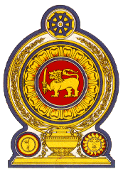

48th Session of the Universal Periodic Review

**Review of Slovenia**– 28th January 2025

Statement by the Democratic Socialist Republic of Sri Lanka

Mr. President,

Sri Lanka welcomes the delegation of Slovenia and appreciates the presentation made.

Sri Lanka commends the ratification by Slovenia of the International Convention for the

Protection of All Persons from Enforced Disappearance in 2021 and measures taken to

improve the efficiency of the Slovenian justice system.

In a constructive spirit, Sri Lanka recommends that Slovenia;

1. Continues to cater to the housing needs of vulnerable groups.
2. Strengthens efforts to eradicate barriers that hinder women's participation in politics.
3. Continues efforts to combat discrimination on the grounds of disability.
4. Ratifies the International Convention on the Protection of the Rights of All Migrant Workers and Members of Their Families.
5. Provides asylum-seekers with adequate and safe accommodation.

We wish Slovenia success in its UPR engagement.