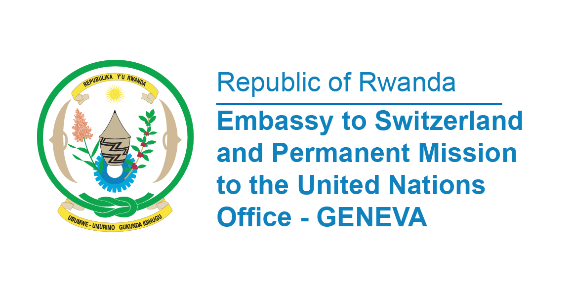

**48th Session of the UPR Working Group**

**Review of Slovenia**

**28th January 2025**

**Statement delivered by Permanent Mission of the Republic of Rwanda**

Thank you, Mr. President,

Rwanda welcomes the high-level delegation of the Republic of Slovenia and thanks them for the presentation of their National Report and the implementation of recommendations from previous cycles.

We commend the reform aimed at establishing the office of a Child Rights Ombudsman to deal exclusively with the rights of children.

We further commend the amendment to the Criminal Code in 2023 introducing hate crime as a mandatory aggravating circumstance to be considered in sentencing offences committed out of hatred or prejudice based on the personal circumstances of the victim.

In a constructive spirit, Rwanda recommends Slovenia the following;

* Consider ratifying the International Convention on the Protection of the Rights of All Migrant Workers and Members of Their Families,
* Consider acceding to the Optional Protocol to the International Covenant on Economic, Social and Cultural Rights;
* Consider acceding to the 1961 Convention on the Reduction of Statelessness.

Rwanda wishes Slovenia a successful review.

**Thank you**