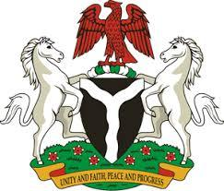

*Please check against delivery*

**HUMAN RIGHTS COUNCIL**

**48TH SESSION OF THE WORKING GROUP OF THE UPR**

**REVIEW OF SLOVENIA**

**28TH JANUARY, 2025**

**STATEMENT BY NIGERIA**

**Mr President**,

Nigeria welcomes the delegation of the Republic of Slovenia to the presentation of its National Report for the Fourth UPR Cycle and commends the Government for its efforts to combat human trafficking. We further commend the Government’s policy on migration and the protection of the rights of migrants.

2. In the spirit of constructive dialogue, Nigeria wishes to recommend to Slovenia as follows:

1. To consider further necessary measures to protect migrants and refugees, including by ratifying the International Convention on the Protection of the Rights of all Migrant Workers and Members of their Families;
2. To continue and intensify efforts to combat human trafficking by strengthening victim protection mechanisms, providing support services and ensuring the effective prosecution of traffickers; and
3. To ensure that relevant laws and policies respect the rights and duties of parents or legal guardians of children, in accordance with international law

4. Finally, we wish Slovenia a very successful review process.

I thank you Mr President.