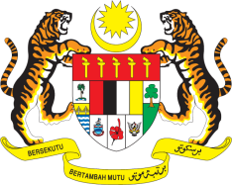

**STATEMENT BY MALAYSIA**

**REVIEW OF SLOVENIA**

**48TH SESSION OF THE UPR WORKING GROUP**

**20 – 31 JANUARY 2025**

Malaysia thanks Slovenia for the presentation of its national report.

1. Malaysia commends Slovenia for implementing recommendations from previous reviews, including those provided by Malaysia. We acknowledge Slovenia's commitment to combating hate speech, as reflected in its Constitution, and the criminalisation of hate speech under its Criminal Code. We strongly urge Slovenia to ensure these measures are applied consistently and without bias.
2. In the spirit of constructive engagement, Malaysia recommends the following:
   1. First, enhance Slovenia's hate speech prevention strategy to fully address all forms of religious discrimination, including Islamophobia; and
   2. Second, ensure access to basic health, nutrition, education, protection, water and sanitation services for all children, in particular children with disabilities and Roma children.
3. We wish Slovenia a successful review.

Thank you.

**28 JANUARY 2025**

**GENEVA**