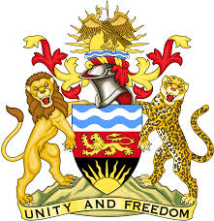

**REPUBLIC OF MALAWI**

**MALAWI STATEMENT ON SLOVENIA UNIVERSAL PERIODIC REVIEW**

**TUESDAY, 28TH JANUARY 2025**

**Mr. President**,

Malawi warmly welcomes Slovenia to this review and thanks the distinguished delegation for the comprehensive report.

In the spirit of constructive dialogue, Malawi makes the following recommendations to Slovenia:

1. Consider ratifying the Optional Protocol to the International Covenant on Economic, Social and Cultural Rights; and
2. Strengthen access to inclusive education for women and girls with disabilities

We wish Slovenia all the best at this review and in the implementation of the recommendations.

**Thank you, Mr. President**.