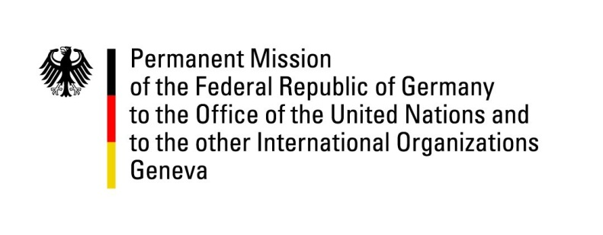

**United Nations Human Rights Council**

**48th Session of the UPR Working Group**

**Geneva, 28January 2025**

**German Recommendations to**

**Slovenia**

Mister/Madam (Vice-)President,

Germany welcomes the delegation of Slovenia and commends Slovenia for its strong commitment to the protection of human rights. Germany particularly welcomes Slovenia’s recent legislation to strengthen freedom and independence of the press, esp. for the public broadcaster RTV Slovenja, and invites Slovenia to take further measures to support a conducive environment for journalists, including measures against harassment and against political interference in the media landscape.

By identifying health care reform as a political priority, Slovenia proved its commitment to tackling issues in this area.

Germany also values Slovenia’s efforts to address the precarious situation of Roma in south-eastern Slovenia. Nevertheless, Germany reiterates its call to further strengthen efforts to improve the living conditions of Roma.

Germany therefore recommends to:

* accelerate reform efforts in the health sector, with a view to reducing waiting times for patients and improving access to primary health care;
* implement further measures to improve the living conditions of Roma, especially with regard to providing fundamental public services such as water and access to education for children;
* accelerate the full-scale implementation of Slovenia’s antisemitism strategy, with a view to strengthening awareness-raising across authorities and civil society.

Germany wishes Slovenia all the best for a successful review.

Thank you, Mr./Madam (Vice-) President.