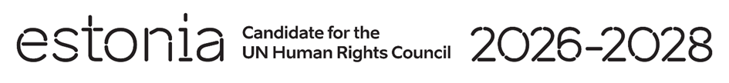

**Universal Periodic Review of Slovenia**

**28 January 2025**

**Intervention by the delegation of Estonia**

**1min 15 sec**

Estonia welcomes the delegation of Slovenia to its fourth UPR. We thank Slovenia for its national report and for the information provided today. We commend Slovenia for ratifying the International Convention for the Protection of All Persons from Enforced Disappearance and for various initiatives undertaken to advance human rights domestically. We also commend the efforts made to ensure a comprehensive approach to migration management and migrant inclusion through relevant national strategies.

We recommend to:

* remove all exceptions to the legal minimum age of marriage at 18 for both women and men;
* continue developing programs to promote digital inclusion and integrate digital literacy education into school curricula;

We wish Slovenia a successful review.

Thank you.