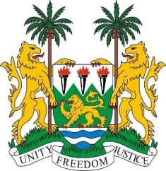

**SIERRA LEONE**

**48th Session of the UPR**

**REVIEW OF ITALY**

Monday, 20th JANUARY 2025

1minute **Check against delivery.**

**Mr. President**,

Sierra Leone welcomes and thanks **Mr. Giorgio Silli, Undersecretary, Ministry of Foreign Affairs and International Cooperation** and the distinguished delegation from Italy for the presentation of its national report.

My delegation commends Italy's series of policy initiatives aimed at addressing family matters. We acknowledge the 2024 budget law, through which the government has allocated approximately 1 billion euros to measures that support families and promote birth rights.

While acknowledging the country’s efforts in addressing smuggling, human trafficking, and its migration strategy, we offer the following recommendations to address existing gaps:

1. Consider strengthening collaboration with the International Organization for Migration to address migration more effectively.
2. Take concrete steps to combat racism, racial discrimination, and other forms of intolerance, particularly against ethnic minorities and migrant communities.
3. Implement measures to address the unlawful detention of migrants in facilities referred to as hotspot centers.

Sierra Leone wishes the Italian Republic a successful fourth-cycle review.

**Thank you, Mr. President.**