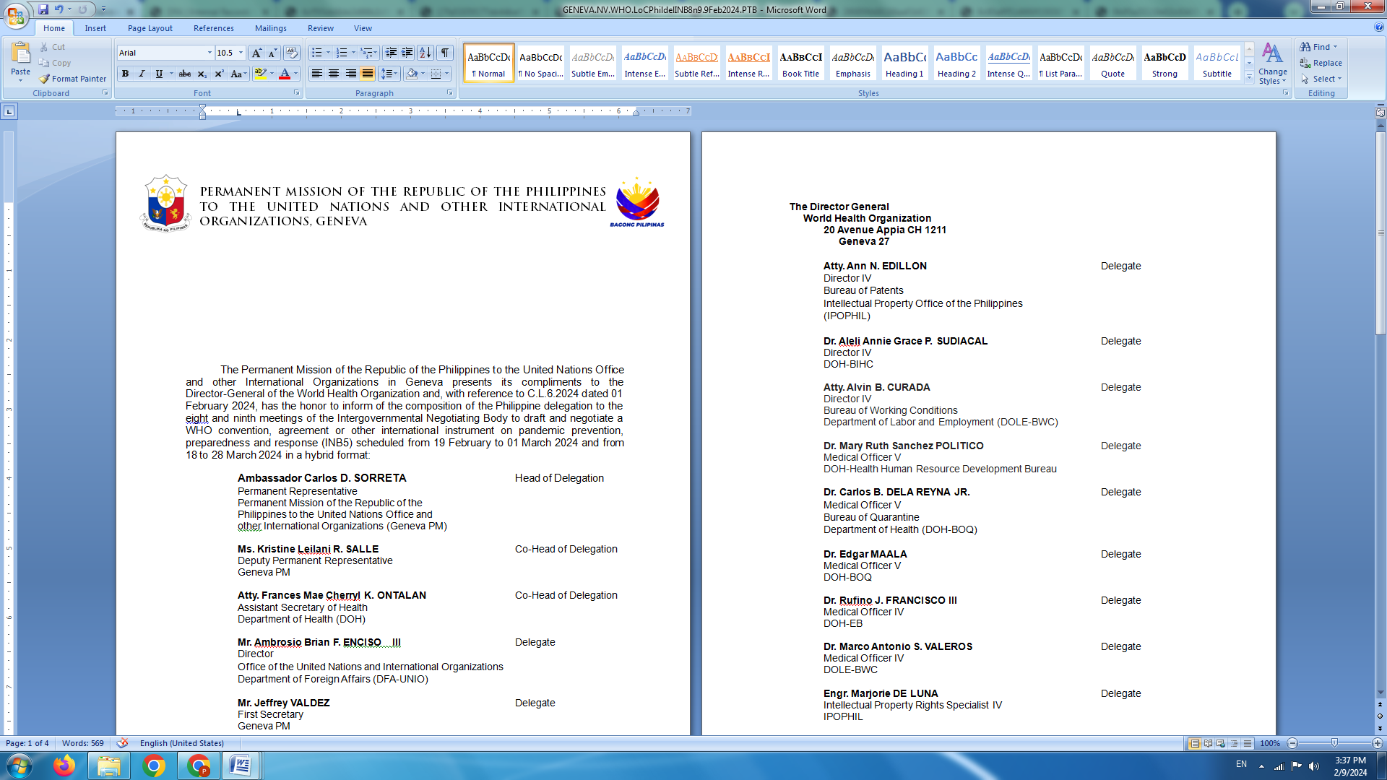

**Human Rights Council**

**48th session of the Working Group on the Universal Periodic Review**

**Universal Periodic Review of ITALY**

20 January 2025, 9:00 AM – 12:30 PM

Palais des Nations, Room XX

To be delivered by:

**Luningning Camoying Valdez**

*First Secretary*

*Speaking Time: 1 minute*

Mr. President, we warmly welcome the delegation of Italy and recognize the important steps taken to strengthen national human rights framework during the review period. We particularly laud concrete justice sectors reforms and adoption of the Guidelines on Civic Education making human rights education compulsory starting at kindergarten.

To build on these gains, allow us to recommend the following:

1. Strengthen legal migration pathways and continue to ensure that the rights and safety of refugees and asylum seekers, particularly women and children, are upheld at all times in line with international obligations;
2. Further intensify efforts to combat racism, including racial profiling by law enforcement officials, and hate speech affecting minorities, migrants, and other groups in vulnerable situations; and
3. Further bolster mechanisms to stem out labor exploitation and illegal recruitment of migrant workers in the agricultural sector.

Noting the profound impact of the climate crisis on human rights, we hope that Italy will pursue deep, rapid and sustained mitigation measures, and add its strong voice to push for meaningful climate action, including financing for loss and damage, based on the principles of equity and climate justice.

Thank you. END