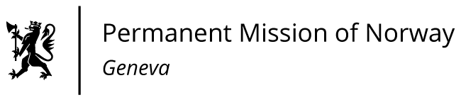

**48th SESSION OF THE UPR WORKING GROUP   
Statement Norway**

**on the on the human rights situation in Italy,**

**delivered by Mr Tormod C. ENDRESEN**

**Ambassador - Permanent Representative to the UN and other International Organizations.**

Check against delivery

20 January 2025

President,

Norway thanks the Italian delegation for its report. Norway acknowledges Italy’s efforts to improve women's rights, particularly steps to combat gender based-violence. However, further progress is needed.

Norway recommends that Italy:

1.Ensures the sexual and reproductive health and rights of women and girls, particularly sufficient access to safe abortion services. Creating an accessible registry of facilities would address information gaps and timely access to care.

2. Combats gender-based violence by implementing preventive measures, including comprehensive sex education in schools, and establishing more crisis centers.

3.Protects the right to freedom of expression and assembly by refraining from adopting legislation which criminalizes peaceful protest and legitimate acts of civil disobedience.

Thank you.