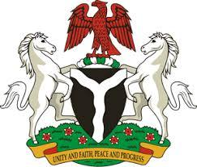

*Please check against delivery*

HUMAN RIGHTS COUNCIL

48TH SESSION OF THE WORKING GROUP OF THE UPR

REVIEW OF ITALY

20TH JANUARY, 2025

**STATEMENT BY NIGERIA**

**Mr President**,

Nigeria welcomes the delegation of Italy to the presentation of its National Report for the Fourth UPR Cycle and commends the Government for its cooperation with human rights mechanisms.

2. Nigeria acknowledges the commitment of the Government of Cyprus to uphold human rights, particularly its efforts to protect the rights of migrants and combat human trafficking, including through the adoption and implementation of the second National Action Plan 2022-2025 to combat trafficking and serious exploitation of human beings

3. In the spirit of constructive dialogue, Nigeria wishes to recommend to Italy as follows:

1. To consider further necessary measures to ensure the protection of the rights of migrants and refugees, including through the ratification of the Convention on the Protection of the Rights of all Migrant Workers and Members of their Families;
2. To continue with its efforts in combating human trafficking and upholding the rights of its victims.

4. In conclusion, we wish Italy every success in its review process.

I thank you Mr President.

**********************************************************************************