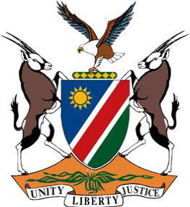

**Statement by Namibia at the 48th Session of the UPR Working Group:**

**Review of Italy, 20 January 2025**

**Mr. President,**

1. Namibia warmly welcomes the delegation of Italy.
2. In the spirit of constructive dialogue, we wish to offer two following recommendations:

**First,** ensure that all refugees have access to effective anti-discrimination

measures and safeguards, in particular in the areas of job inclusion and housing; and

**Second,** include in national legislation a prohibition of racial profiling and ensure that the police and other law enforcement officials are provided with clear guidelines aimed at preventing racial profiling during police checks, identity checks and other police measures.

We wish Italy a successful fourth review.

**Thank you!**