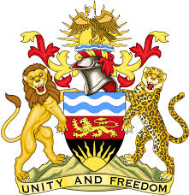

**REPUBLIC OF MALAWI**

**MALAWI STATEMENT ON ITALY UNIVERSAL PERIODIC REVIEW**

**MONDAY, 20TH JANUARY 2025**

**Mr. President**,

Malawi welcomes Italy to this review and thanks the delegation for the comprehensive presentation.

In the spirit of constructive dialogue, Malawi makes the following recommendations to Italy:

1. Accelerate the establishment of a National Human Rights Institution (NHRI) aligned with Paris Principles;
2. Continue with efforts to increase female representation both in public and private sector.

We wish Italy all the best at this review and in the implementation of the recommendations.

**Thank you, Mr. President**.