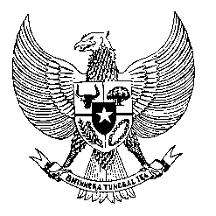

Permanent Mission

of the Republic of Indonesia to the UN, WTO,

and Other International Organizations

in Geneva

**STATEMENT BY THE DELEGATION OF THE REPUBLIC OF INDONESIA**

**AT THE 48th SESSION OF THE UPR WORKING GROUP**

**REVIEW OF ITALY**

**20 JANUARY 2025**

**Thank you, Mr. President**

* We welcome Italy’s participation in the UPR process and thank them for its report.
* We welcome Italy’s progress achieved since last UPR, including the adoption of Second National Action Plan on Business and Human Rights (2021–2026).
* However, we note the prevalence of human trafficking cases and racial hate crimes against migrants in Italy.
* In a constructive spirit, Indonesia recommends that Italy:
  1. Enhance the protection of the rights of all migrant workers, their family members and the seafarers.
  2. Take more effective measures to eliminate racial hatred and racial profiling.
  3. Increase reporting, investigation, and prosecution of human trafficking cases.
  4. Continuously ensure that its arms transfers and exports always comply with international human rights and humanitarian laws.
* Finally, we wish Italy a successful UPR.
* Thank you.