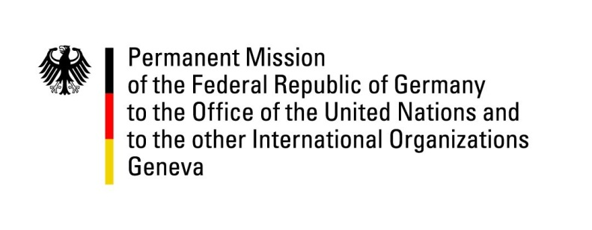

**United Nations Human Rights Council**

**48th Session of the UPR Working Group**

**Geneva, 20 January 2025**

**German Recommendations to**

**Italy**

Mister President,

Germany welcomes the delegation of the Republic of Italy and highly commends the strong and sincere engagement of Italy with the Universal Periodic Review (UPR) process.

In particular, Germany commends recent steps against gender-based violence, including public awareness campaigns, additional helplines, additional preventive emergency measures, the acceleration of investigations and judicial proceedings, as well as the strengthening of electronic surveillance measures.

However, Germany invites Italy to make further progress in the protection of migrant workers from exploitation and in protecting press freedom.

Germany therefore recommends to:

* Strengthen efforts to prevent and to combat the exploitation of migrant workers (“caporalato”), especially in the agricultural sector, and to ensure fair and safe working conditions;
* Follow up on the EU’s proposal to reform the press defamation regime while avoiding any negative impacts on press freedom and ensure European standards on the protection of journalists.

We wish Italy a successful review process.

Thank you, Mister President.