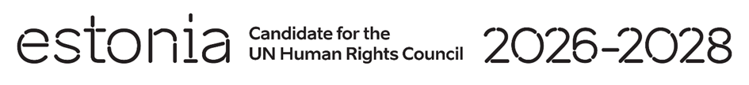

**Universal Periodic Review of Italy**

**20 January 2025**

**Intervention by the delegation of Estonia**

Estonia warmly welcomes the delegation of Italy to its fourth UPR. We thank Italy for its national report and the information provided today.

We welcome Italy’s progress in promoting gender equality and countering gender-based violence, in particular the adoption of the Gender Equality Strategy 2021-2026. We also welcome efforts to protect children’s privacy online.

We encourage the Government to continue its efforts to support the participation of women in the labor market and facilitate the reconciling of work and family life.

We would like to recommend to Italy to:

* continue working on equal rights for LGBTQI+ people;
* accelerate the establishment of a National Human Rights Institution in line with the Paris Principles.

We wish the delegation of Italy a successful review meeting.

Thank you.