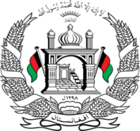

**Permanent Mission of Islamic Republic of Afghanistan**

**48th Session of the UPR Working Group**

**Statement on the Review of Italy**

Afghanistan welcomes the distinguished delegation of Italy and thanks them for their detailed presentation.

We commend Italy for giving specific attention to the most vulnerable groups among the migrant and asylum seeker populations, such as women and underaged children.

**Mr./Mme. (Vice) President,**

In the spirit of constructive engagement, my delegation wishes to make the following recommendations:

1. Ensure that the principle of non-refoulement is upheld for all women and girls in need of international protection and that no asylum-seeker or migrant is expelled from the country without an individual risk assessment.
2. Ensure that any engagement with the Taliban *de facto* authorities is contingent on and centered around their respect for the human rights and fundamental freedoms of the people of Afghanistan, especially those of women, children, persons with disabilities, and minorities.

Finally, we wish Italy every success in the UPR Review Process.

I thank you.