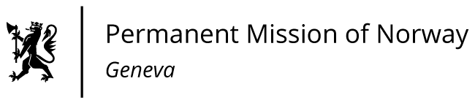

**48th SESSION OF THE UPR WORKING GROUP   
Statement Norway**

**on the on the human rights situation in Iran,**

**delivered by Mr Tormod C. ENDRESEN**

**Ambassador - Permanent Representative to the UN and other International Organizations.**

Check against delivery

24 January 2025

President,   
  
Norway welcomes the efforts to secure education and health care for Afghan nationals in Iran. However, several human rights concerns remain.  
  
Norway recommends that Iran:   
  
1. Abolishes discriminatory legal provisions against minorities and women and ratifies CEDAW.

2. Abolishes the death penalty and stops planned executions for persons who committed crimes while below the age of 18 and ensures that Iran fully comply with the Convention on the Rights of the Child, ratified by Iran.

3. Ceases the censorship of the media, as well as the arbitrary detention and intimidation of journalists and human rights defenders, online and offline.

4. Ensures the rights of detainees and prisoners, including timely and adequate medical treatment and preventive measures such as screening.    
  
I Thank you.