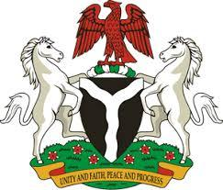

*Please check against delivery*

**HUMAN RIGHTS COUNCIL**

**48TH SESSION OF THE WORKING GROUP OF THE UPR**

**REVIEW OF THE ISLAMIC REPBULIC OF IRAN**

**24TH JANUARY, 2025**

**STATEMENT BY NIGERIA**

**Mr President**,

Nigeria welcomes the delegation of the Islamic Republic of Iran to the presentation of its National Report for the Fourth UPR Cycle. We commend the Government for its cooperation with human rights mechanisms, including the UPR process and efforts in implementing previous recommendations.

2. We take positive note and commend Iran for its achievement in the provision of healthcare services, bridging the education gap and implementing social welfare programs, particular for older persons and persons with disabilities

3. While acknowledging the efforts of the Government of Iran to promote and protect human rights, Nigeria wishes to recommend as follows:

1. To continue efforts in promoting and protecting the rights of women and girls, as well as persons with disabilities: and
2. To sustain and enhance initiatives aimed at improving the socio-economic well-being of its people.

4. In conclusion, we wish Iran every success in its review process.

I thank you Mr President.