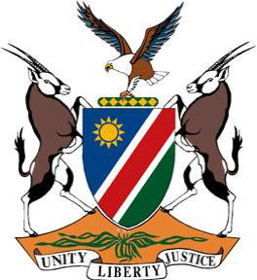

**Statement by Namibia at the 48th Session of the UPR Working Group:**

**Review of the Islamic Republic of Iran, 23 January 2025**

**Mr. President,**

1. Namibia warmly welcomes the delegation of the Islamic Republic of Iran to the fourth UPR cycle and thanks them for their comprehensive national report. We commend the development, in 2023, of a bill on protecting women against violence and promoting their dignity and security.
2. In the spirit of constructive dialogue, we wish to offer the following recommendations:

**One,** ratify the core international human rights treaties and optional protocols to which Iran is not yet a party, in particular, the Convention on the Elimination of All Forms of Discrimination against Women, the Convention against Torture and Other Cruel, Inhuman or Degrading Treatment or Punishment, and the International Convention for the Protection of All Persons from Enforced Disappearance;

**Two,** intensify efforts to establish a national human rights institution in accordance with the principles relating to the status of national institutions for the promotion and protection of human rights (the Paris Principles); and

**Three,** take steps to abolish the death penalty and introduce an immediate moratorium on its use.

1. We wish the Islamic Republic of Iran a successful fourth review.

**I thank you!**