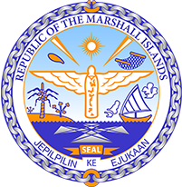`

**Republic of the Marshall Islands**

**STATEMENT by Mr. Samuel K. Lanwi Jr.**

**48th Session of the Universal Periodic Review Working Group**

**24 January 2025**

**Geneva**

4th Cycle Review of the Islamic Republic of Iran

*Check against delivery*

Thank you, Mr. President.

The Republic of the Marshall Islands thanks the esteemed delegation of the Islamic Republic of Iran for their report.

We recommend the following:

1. Abolish the death penalty for all crimes without exception;

2. Take steps towards the ratification of the Convention Against Torture;

3. Adopt concrete measures to eliminate discrimination and enhance the protection of the human rights of the Baha’is and other minority communities in the country;

4. Urgently undertake measures to promote and protect women’s rights, including the ratification of the CEDAW;

5. Align its NDCs with the Paris Agreement goal of limiting global warming to 1.5 degrees Celsius above pre-industrial levels.

Kommol tata and I thank you.