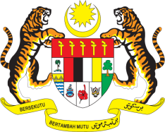

**STATEMENT BY MALAYSIA**

**REVIEW OF THE ISLAMIC REPUBLIC OF IRAN**

**48TH SESSION OF THE UPR WORKING GROUP**

**20 – 31 JANUARY 2025**

Malaysia thanks the Islamic Republic of Iran for the presentation of its national report.

1. Malaysia acknowledges the challenges Iran faces due to unilateral coercive measures that negatively impact human rights. We welcome Iran’s continuous engagement with human rights mechanisms and encourage Iran to continue this constructive engagement to further improve the human rights situation in the country.
2. In the spirit of constructive engagement, Malaysia recommends the following:
   1. First, expedite efforts to establish a National Human Rights Institution in line with the Paris Principles;
   2. Second, enhance cooperation with the thematic special procedures of the Human Rights Council by considering their country visits.
   3. Third, increase efforts to enhance women’s representation in leadership and decision-making roles.
3. We wish the Islamic Republic of Iran a successful review.

Thank you.

**24 JANUARY 2025**

**GENEVA**