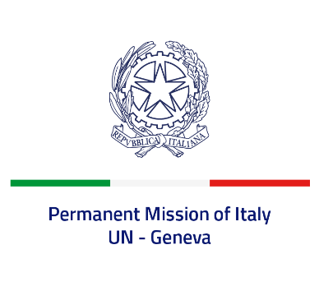

*Check against delivery*

**UPR 48 – Iran**

**Friday 24 January 2025, 09:00 – 12:30**

**Delivered by:  Permanent Representative of Italy Amb. Vincenzo Grassi**

Thank you, Mr. President.

Italy welcomes the delegation of Iran and takes note of the efforts carried out since the third UPR cycle.

Italy recommends Iran to:

* *Introduce a moratorium on executions, with a view to the complete abolition of the death penalty, and ban executions for crimes committed by minors. Introduce alternatives punishments for drug-related crimes.*
* *Strengthen the efforts to combat all forms of discrimination and harmful practices against women and girls – including by refraining from adopting mandatory dress codes and by raising to 18 years the minimum legal marriage age.*
* *Take the necessary measures to guarantee equal rights for all citizens and counter the discrimination of ethnic and religious minorities – with particular regard to Baha’is.*

* *Guarantee freedom of opinion, expression and assembly and cease arresting human rights defenders peacefully exercising these rights.*

Italy wishes Iran a successful UPR.

Thank you.