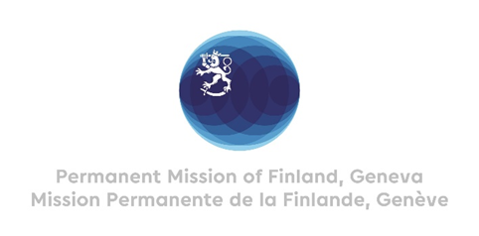

**48th Session of the UPR working group**

**Recommendations by Finland to Iran**

**24 January 2025**

President,

Finland welcomes the engagement of Iran in the UPR process. Finland remains highly concerned by the overall human rights situation in Iran and recommends Iran to:

1) First, implement its international obligations to ensure the rights to freedom of opinion and expression, assembly and association in compliance with international human rights law, and to ensure that all investigations, prosecutions and trials meet international standards.

2) Second, to abolish discriminatory legislation and create policies and practices to prevent all forms of violence against women and girls, and promptly investigate and prosecute all such cases.

3) Third, to abolish the use of death penalty and immediately establish an official moratorium on executions.

We wish Iran a successful review.

Thank you.