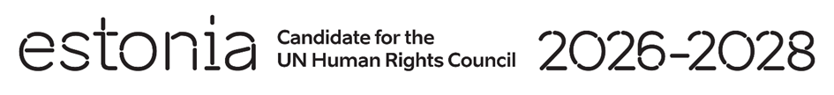

**Universal Periodic Review of the Islamic Republic of Iran**

**24 January 2025**

**Intervention by the delegation of Estonia**

**1 minute and 5 seconds**

Estonia thanks the Islamic Republic of Iran for its constructive engagement with the UPR process.

However, we regret Iran’s continuing non-cooperation with the UN Independent International Fact-Finding Mission. We are truly concerned about reports on persistent and widespread violence against women and girls and further restrictions on civil and political rights.

We recommend to:

* adopt a comprehensive law criminalizing all forms of violence against women and girls that explicitly addresses domestic violence and crimes committed in the name of so-called “honor”;
* amend laws that are used to arbitrarily restrict freedom of expression online and offline and cease internet shutdowns, blocking of social media and other communication platforms.
* Establish a moratorium on the application of the death penalty;
* engage and cooperate with the mandate of the UN Special Rapporteur and the UN Fact-Finding Mission, including by allowing them to visit the country;
* End discrimination on any grounds, including of religious minorities such as the Baha`is.
* ratify the Convention on the Elimination of All Forms of Discrimination against Women (CEDAW), the Rome Statute of the International Criminal Court, the Convention against Torture and Other Cruel, Inhuman or Degrading Treatment or Punishment (CAT) and its Optional Protocol (OP-CAT).

We wish the Islamic Republic of Iran a successful review.

Thank you.