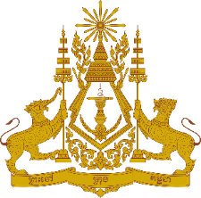

**PERMANENT MISSION OF THE KINGDOM OF CAMBODIA**

**TO THE UNITED NATIONS AT GENEVA**

**Statement by Cambodia**

**Review on Iran**

At the 48th Session of the UPR Working Group

24 January 2025

From 09:00-12:30

[Speaking Time: ~1 minute]

-------

Thank You, Mr. President!

1. Cambodia warmly welcomes the distinguished delegation of Islamic Republic of Iran and highly appreciates the comprehensive National report presented.
2. Cambodia recognizes Iran's engagement with the UPR mechanism and its efforts to implement accepted recommendations demonstrate a commitment to improving human rights. We also applaud Iran’s ongoing commitment to enhance social and economic development particularly on women’s empowerment, children and women's rights through its national initiatives and policies.
3. In the constructive spirit, Cambodia ​would like to make the following recommendations:
4. Continue implementing its national policy particularly with regard to the social protection programmes that support women, children and minority rights; and
5. Continue strengthening its cooperation and national policies to empower rural women and enhance their economic and social role in the country.
6. Lastly, Cambodia wishes Iran a successful review.

Thank you,

*\*\*\*\*\**