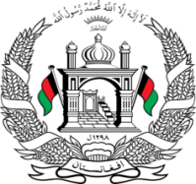

**Permanent Mission of Islamic Republic of Afghanistan**

**48th Session of the UPR Working Group**

**Statement on the Review of Iran**

Thank you,

Afghanistan welcomes the distinguished delegation of the Islamic Republic of Iran and thanks them for their detailed presentation.

While appreciating Iran’s generous hospitality to millions of refugees from Afghanistan for decades, the situation under the Taliban remains of utmost concern. We urge Iran to continue its efforts in providing protection and support to refugees, particularly those who fled the country following the Taliban's military takeover in August 2021.

**Mr./Mme. (Vice) President,**

In the spirit of constructive engagement, my delegation wishes to make the following recommendations:

1. Ensure that all refugees within the territory of the Islamic Republic of Iran are guaranteed their basic human rights and are protected from forced expulsion.

2. Intensify efforts to enhance the protection of human rights of refugees within the territory of Iran, with a particular focus on ensuring their access to essential services such as healthcare and education.

Finally, we wish the Islamic Republic of Iran every success in the implementation of accepted recommendations.

I thank you.