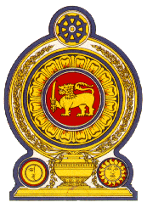

48th Session of the Universal Periodic Review

**Review of the Gambia**– 21st January 2025

Statement by the Democratic Socialist Republic of Sri Lanka

Mr. President,

Sri Lanka welcomes the delegation of the Gambia and appreciates the presentation made.

Sri Lanka commends the measures taken by the Gambia to increase investments in upgrading healthcare infrastructure, particularly in rural areas, and enhancing trainings for health extension workers. The implementation of the National Nutrition Policy prioritizing the nutritional needs of vulnerable groups is also noteworthy.

In a constructive spirit, Sri Lanka recommends that the Gambia;

1. Continues efforts to reduce maternal and infant mortality
2. Strengthens efforts to improve access to education in the rural areas.
3. Takes specific measures to ensure that children’s dietary requirements are met.
4. Facilitates universal birth registration.
5. Takes measures to stop the practice of female genital mutilation and rehabilitate victims.

We wish the Gambia success in its UPR engagement.