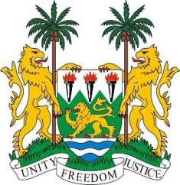

**SIERRA LEONE**

**48th Session of the UPR**

**REVIEW OF GAMBIA**

Tuesday, 21 January 2024

**Check against delivery.**

Mr. President,

Sierra Leone warmly welcomes and thanks **Honourable Mr. Dawda A. Jallow, Minister of Justice** and the distinguished delegation from The Gambia for the presentation of its national report.

My delegation commends the Gambia for its significant progress in promoting human rights. This includes the establishment of the National Human Rights Commission and other transitional justice mechanisms, as well as its ongoing efforts to address gender inequality and education.

In a spirit of constructive dialogue, Sierra Leone wishes to make the following recommendations:

1. Continue implementing measures that promote gender equality, with a particular focus on public spaces.

1. Ratify the Optional Protocol to the Convention on the Elimination of All Forms of Discrimination against Women, reinforcing its dedication to the protection and promotion of women's rights.

1. To Consider taking concrete measures to address caste and descent-based discrimination to ensure social harmony within its society.

Sierra Leone acknowledges the brotherly Republic of The Gambia's commitment to the UPR process and wishes it a successful review.

Thank you, Mr. President.