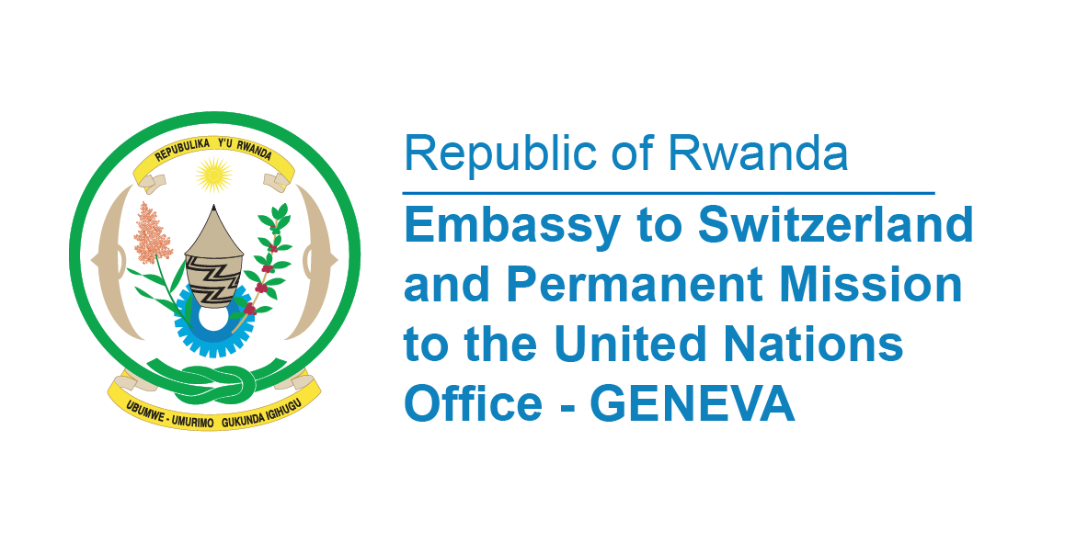

**48th Session of the UPR Working Group**

**Review of The Gambi**

**21st January 2025**

**Statement delivered by Permanent Mission of the Republic of Rwanda**

Thank you, Mr. President,

Rwanda welcomes the high delegation of the Republic of The Gambia and thanks them for the presentation of their National Report.

We appreciate The Gambia’s strong commitment to ensure security and accountability, fostering democracy, respect for the rule of law, good governance, and promoting access to justice.

We commend The Gambia’s ongoing legislative efforts including the revision of the Criminal Code and other domestic laws to ensure they align with international best practices.

In a constructive spirit, Rwanda recommends The Gambia the following,

* To consider ratifying the Optional Protocol to the Convention on the Elimination of All Forms of Discrimination against Women;
* Ratifying the Optional Protocol to the Convention on the Rights of the Child s; and finally
* Consider ratifying the Optional Protocol to the International Covenant on Economic, Social and Cultural Rights.

Rwanda wishes the Gambia a successful review process.

**Thank you**