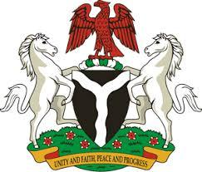

*Please check against delivery*

**HUMAN RIGHTS COUNCIL**

**48TH SESSION OF THE WORKING GROUP OF THE UPR**

**REVIEW OF THE GAMBIA**

**21ST JANUARY, 2025**

**STATEMENT BY NIGERIA**

**Mr. President,**

Nigeria warmly welcomes the delegation of the brotherly Republic of the Gambia to the presentation of its National Report for the Fourth UPR Cycle. We commend the Government for its continued cooperation with human rights mechanisms and efforts in the implementation of previous recommendations.

2. We further applaud the Gambian Government for its achievements in its reform agenda, particularly the enactment of the Access to Information Act of 2021 and the Anti-Corruption Act of 2023. These legislative advancements demonstrate a commitment to transparency, accountability, and good governance, which are crucial for the protection and promotion of human rights

3. While recognising the efforts and commitments of the Gambia to promote and protect human rights, Nigeria wishes to recommend as follows:

1. To strengthen efforts to protect and promote the rights of persons with disabilities, including by intensifying the implementation of Persons with Disabilities Act, 2021; and
2. To continue its efforts in enhancing the socio-economic well-being of its people and ensuring their full enjoyment of human rights.

4. Finally, we wish the Gambia a very successful review process.

I thank you, Mr. President.