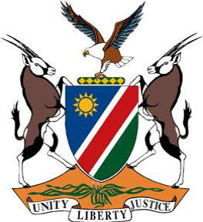

**Statement by Namibia at the 48th Session of the UPR Working Group:**

**Review of the Gambia, 21 January 2025**

**Mr. Vice-President,**

1. Namibia warmly welcomes the esteemed delegation of the Gambia. We commend the Gambia for taking significant steps to address violence against women and girls, notably by criminalizing Female Genital Mutilation through the enactment of the 2015 Amendment Act, which paved the way for the country’s first ever FGM conviction in 2023.
2. We further commend the Gambia for taking notable measures to ratify and domesticate all core international human rights treaties.
3. In the spirit of constructive dialogue, we wish to offer the following recommendations:

**One,** ratify core optional protocols to which the Gambia is not yet a party. In particular, the Optional Protocol to the Convention on the Elimination of All Forms of Discrimination against Women, and the Optional Protocol to the Convention on the Rights of the Child on a communications procedure; and

**Two,** address the cultural beliefs underlying the harmful practice of FGM aimed at its complete elimination.

1. We wish the Gambia a successful fourth review.

**I thank you!**