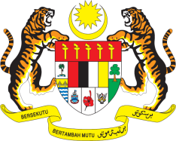

**STATEMENT BY MALAYSIA**

**REVIEW OF THE REPUBLIC OF THE GAMBIA**

**48TH SESSION OF THE UPR WORKING GROUP**

**20 – 31 JANUARY 2025**

Malaysia thanks The Gambia for the presentation of its national report.

1. Malaysia commends The Gambia for its progress in human rights and socio-economic development. Notable achievements include the modernization of agriculture under the Recovery-Focused National Development Plan 2023-2027 and the enactment of the National Social Protection Act 2024, which all aimed to enhance food security and the delivery of essential social services.
2. In the spirit of constructive engagement, Malaysia recommends the following:
   1. First, increase investments in water infrastructure to provide equitable access to clean and safe drinking water, particularly in rural and underserved areas;
   2. Second, accelerate the adoption of the Mental Health Bill and integrate mental health services into primary healthcare;
   3. Third, enhance nationwide digital literacy programmes to empower citizens to safely engage in the digital environment and utilise technology for socio-economic advancement.
3. We wish The Gambia a successful review.

Thank you.

**20 JANUARY 2025**

**GENEVA**