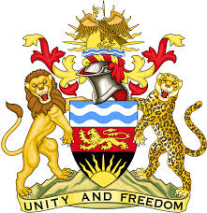

**REPUBLIC OF MALAWI**

**MALAWI STATEMENT ON THE GAMBIA UNIVERSAL PERIODIC REVIEW**

**TUESDAY, 21ST JANUARY 2025**

**Mr. President**,

Malawi welcomes The Gambia to this review and thanks the delegation for the comprehensive presentation.

Malawi commends The Gambia for demonstrating its commitment to implementing international human rights conventions into domestic laws by ratifying all nine core UN human rights treaties and key optional protocols.

In the spirit of constructive dialogue, Malawi makes the following recommendations to The Gambia:

1. Take steps to fully domesticate the International Convention for the Protection of All Persons from Enforced Disappearance;
2. Continue with all efforts to raise public awareness on gender equality.

We wish The Gambia all the best at this review and in the implementation of the recommendations.

**Thank you, Mr. President**.