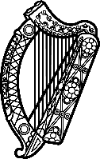

**Statement of Ireland**

**48th session of the UPR Working Group**

Review of The Gambia

**21 January 2025**

Ireland warmly welcomes the delegation of The Gambia and thanks it for its presentation today.

Ireland acknowledges The Gambia’s efforts to advance human rights domestically, including the steps taken to protect the rights of persons living with disability and the enacting of the Persons with Disabilities Act.

We also welcome efforts made to progress the recommendations of the Truth, Reconciliation and Reparations Commission.

Unfortunately, despite the national ban on Female Genital Mutilation, the practice of FGM remains widespread.

Ireland recommends The Gambia to:

1. Continue efforts to abolish the death penalty permanently by amending the relevant constitutional and legislative provisions.
2. Address the cultural beliefs and social norms that underpin the practice of FGM, and enforce the Women’s (Amendment) Act 2015.

We wish The Gambia every success in this UPR cycle. Thank you.