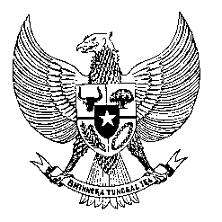

Permanent Mission

of the Republic of Indonesia to the UN, WTO,

and Other International Organizations

in Geneva

**STATEMENT BY THE DELEGATION OF THE REPUBLIC OF INDONESIA**

**AT THE 48th SESSION OF THE UPR WORKING GROUP**

**REVIEW OF THE GAMBIA**

21 JANUARY2025

**Thank you, Mr. President,**

Indonesia warmly welcomes the distinguished delegation of the Gambia and appreciates its continued constructive engagement within the UPR mechanism.

We commend Gambia's ongoing commitment to advancing human rights, particularly through initiatives such as the National Health Policy 2021–2030 and the National Development Plan 2023–2027, which promote accessible healthcare services. We also welcome Gambia's efforts in pursuing institutional and legal reforms, including the establishment of a new constitution to be tabled later this year, as well as the revision of the Criminal Code and the Criminal Procedure Code.

In the spirit of constructive cooperation, Indonesia wishes to recommend Gambia to:

1. Intensify efforts to increase the participation of women in politics and leadership positions, including through capacity-building programs and affirmative actions.
2. Enhance efforts to reduce maternal mortality and morbidity, including through improving access to obstetric and neonatal care.
3. Continue efforts to improve access to education for girls as well as children with disabilities.

We wish the Gambia a successful UPR. Thank you.

*Word Count: 169 words*

*Max. Speaking Time: 1 minute*