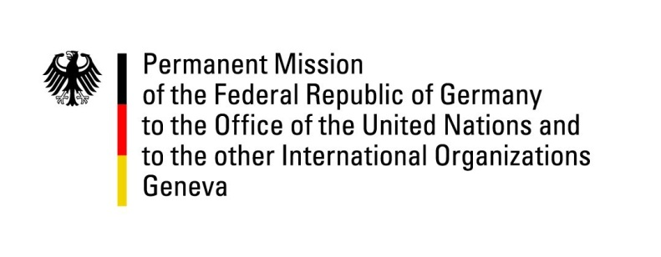

**United Nations Human Rights Council**

**48th Session of the UPR Working Group**

**Geneva, 21st of January 2025**

**German Recommendations to**

**The Gambia**

Mister President,

Germany welcomes the delegation of the Gambia.

Germany commends the Gambia for its sincere efforts to improve human rights, visible in the continued implementation of the Recommendations of the Truth and Reconciliation Commission, and encourages the Government to advance the implementation as quickly as possible.

Germany also commends the Government and Parliament for upholding the ban on Female Genital Mutilation (FGM) and encourages the Gambia to step up efforts against gender-based violence (GBV) and for equal participation.

With regards to freedom of speech and freedom of information, Germany observes with concern recent short-term arrests of journalists, and calls upon the Government to ensure that journalists are able to work freely and independently at all times.

Germany respectfully recommends:

* To diligently investigate and prosecute all cases of sexual and gender-based violence (SGBV), in particular of FGM, and to create an accessible network and infrastructure where women threatened by SGBV and FGM can find safety and shelter. Women must be informed about their rights and police must be trained for the special circumstances of SGBV cases;
* Invest in active prevention of SGBV and FGM, including through comprehensive education on sexual and reproductive health and rights (SRHR);
* To step up measures to enhance the number of women in public office;
* To enforce provisions on the prohibition of enforced and organized child begging.

Thank you, Mister President.