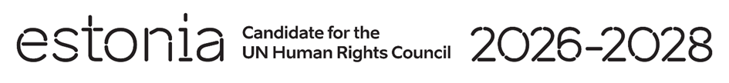

**Universal Periodic Review of Gambia**

**21 January 2025**

**Intervention by the delegation of Estonia**

**1min**

Estonia welcomes the delegation of Gambia to its fourth UPR and commends Gambia’s active role as a member in the Human Rights Council. We also commend the country’s recent efforts to safeguard the rights of women and girls by upholding the law banning female genital mutilation. We also note with appreciation the commitment of the Gambian authorities’ to advancing digital rights.

We are however, deeply concerned about reports of sexual exploitation of children, including through human trafficking.

We recommend to:

* ensure that digital access is inclusive and equitable and to tackle the gender digital divides.
* develop and integrate digital literacy education into school curricula;
* enact a law to clearly prohibit all corporal punishment of children in all settings;
* ensure that domestic laws on data protection and cybersecurity are consistent with international human rights standards;
* ensure universal access to sexual and reproductive health services and modern contraceptives;
* ratify the Optional Protocol to the Convention against Torture and Other Cruel, Inhuman or Degrading Treatment or Punishment (OPCAT)

We wish Gambia a successful review.

Thank you!