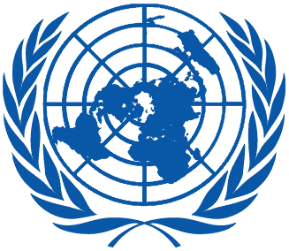 | Working Group on the Universal Periodic Review
Forty-eighth session
Geneva, 20–31 January 2025
Order of the Day
Plenary Meetings Room XX
Friday, 24 January 2025
MORNING
9:00 – 12:30  9th meeting |  | UPR of the Islamic Republic of Iran  - National Report of the Islamic Republic of Iran in accordance with paragraph 15 (a) of the annex to HRC resolution 5/1 and paragraph 5 of the annex to HRC resolution 16/21: A/HRC/WG.6/48/IRN/1  - Compilation prepared by the OHCHR in accordance with paragraph 15 (b) of the annex to HRC resolution 5/1 and paragraph 5 of the annex to HRC resolution 16/21: A/HRC/WG.6/48/IRN/2  - Summary prepared by the OHCHR in accordance with paragraph 15 (c) of the annex to HRC resolution 5/1 and paragraph 5 of the annex to HRC resolution 16/21: A/HRC/WG.6/48/IRN/3
AFTERNOON
15:30 – 18:00  10th meeting |  | Adoption of the recommendations section on:
Italy
- Draft report of the UPR Working Group: A/HRC/59/4
El Salvador
- Draft report of the UPR Working Group: A/HRC/59/5
Gambia
- Draft report of the UPR Working Group: A/HRC/59/6
Plurinational State of Bolivia
- Draft report of the UPR Working Group: A/HRC/59/7
Fiji
- Draft report of the UPR Working Group: A/HRC/59/8
Notes:
All speakers scheduled to take the floor should upload the written version of their oral statements through the online system for inscription on the lists of speakers ( User Login (ohchr.org)) before the opening of the review.
- The full text of statements is available on UPR extranet page
- Conference/meeting participants should enter the Palais des Nations through Pregny Gate (Palais des Nations, 8-14 avenue de la Paix) from 8.00 a.m. to 5.00 p.m.
- PHOTOGRAPHS AND FILMING: Please note that only accredited media are permitted to film and take photographs in the room XX.

