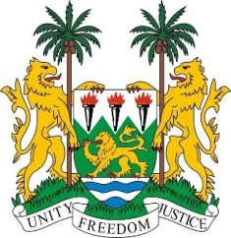

**SIERRA LEONE**

**47th Session of the UPR**

**REVIEW OF NORWAY**

Monday, 4 November 2024

**Check against delivery.**

1minute 10 seconds

Sierra Leone welcomes and thanks **Mr. Even ERIKSEN State Secretary Ministry of Justice and Public Security,** and the distinguished delegation from the Kingdom of Norway for presenting its national report.

My delegation commends Norway for the high degree of gender equality within its society and the measures taken in increasing employment rates among immigrants and in particular women. We commend Norway for its immigration policies, which align with the principle of non-refoulement, as well as its Education Act, which guarantees free education from primary through secondary school

While acknowledging the Kingdom’s progress, we note few gaps and recommend the following:

1. Reconsider the decision to incorporate the Convention on the Rights of Persons with Disabilities into Norwegian law.
2. Continue promoting gender equality, particularly in achieving gender balance in education and ensuring equality in both public and private employment sectors.
3. Accelerate the development of policies to combat Islamophobia, antisemitism, and discrimination against the Sami people.
4. Enhance and strengthen measures to combat racism.

Sierra Leone wishes the Kingdom of Norway a successful fourth-cycle review.

**Thank you, Mr President**.