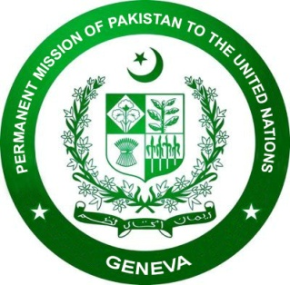

**47th Session of the Universal Periodic Review Working Group**

**National Statement during 4th UPR of Norway**

**(04 November 2024)**

**Mr. President,**

Thank you for giving me the floor.

We join other speakers in welcoming the Norwegian delegation and thanking them for their detailed presentation this morning.

Pakistan appreciates Norway’s ongoing efforts, including those in follow-up to its third UPR, to promote and protect human rights.

The progress achieved by Norway, in particular on gender equality, is commendable.

We also take positive note of Norway’s ongoing work to promote rights of persons with disabilities.

My delegation wishes to make the following two (2) recommendations for consideration:

1. Continue efforts to promote gender equality; and
2. Continue efforts aimed at promoting integration of migrants and countering and combating discrimination and hate crimes, based on race and religion against all minorities, including Muslims.

We wish Norway a productive review.

I thank you.

----