*Check against delivery*

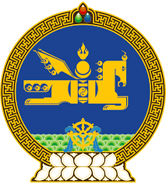

**47th SESSION OF THE UPR WORKING GROUP**

**MONGOLIA’S STATEMENT AT THE REVIEW OF THE KINGDOM OF NORWAY**

**4 November 2024, 09:00 - 12:30 hrs**

(1 min 10 sec)

Mr. President,

Mongolia welcomes the Delegation of Norway and thank for the presentation of the National report.

We note the significant steps, which Norway has taken in human rights, including the high degree of gender equality achieved in its society. We further welcome the new National escalation plan against violence and abuse against children and domestic violence for the period of 2024-2028.

In the spirit of constructive dialogue, Mongolia wishes to offer the following recommendations:

**One.** To consider ratifying the Optional Protocol to the Convention on the Rights of Persons with Disabilities;

**Two.** To ensure full and effective implementation of its National action plan for the implementation of the UN Guiding Principles on Business and Human Rights;

**Three.** To step up its efforts towards the prevention of gender-based violence against women, including by conducting awareness-raising campaigns;

We wish Norway a successful review.

I thank you.

---oOo---