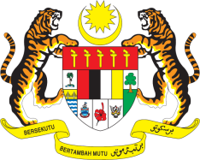

**STATEMENT BY MALAYSIA**

**REVIEW OF NORWAY**

**47TH SESSION OF THE UPR WORKING GROUP**

**4 – 15 NOVEMBER 2024**

Malaysia thanks Norway for the presentation of its national report.

1. Malaysia commends Norway for its continued commitment to the promotion and protection of human rights, as demonstrated by its initiatives, among others, increasing the representation of women in leadership positions, tackling climate change, and integrating human rights into business practices.
2. In the spirit of constructive engagement, Malaysia recommends the following:
   1. First, strengthen legal frameworks to address hate speech and implement mechanisms to monitor and counter online and offline hate speech targeting religious minorities;
   2. Second, expedite the development and implementation of a comprehensive action plan to combat Islamophobia and monitoring system for discriminatory practices;
   3. Third, create a safe digital environment for children through the introduction of a regulation to increase awareness and prevent online exploitation of children;
   4. Fourth, undertake efforts to address disparities in child welfare services to ensure equitable access to child protection and family services, including for children from minority groups.
   5. Fifth, take immediate action to address malnutrition among older persons in health care institutions and effectively prevent violence against older persons.
3. We wish Norway a successful review. Thank you.

**4 NOVEMBER 2024**

**GENEVA**