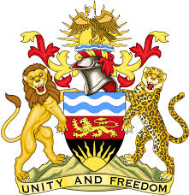

**REPUBLIC OF MALAWI**

**MALAWI STATEMENT ON NORWAY UNIVERSAL PERIODIC REVIEW**

**MONDAY, 4TH NOVEMBER 2024**

**Mr. President**,

Malawi welcomes Norway to this review and thanks the delegation for the comprehensive presentation.

In the spirit of constructive dialogue, Malawi makes the following recommendations to Norway:

1. Consider ratifying the Optional Protocol to the Convention on the Rights of Persons with Disabilities;
2. Consider ratifying the Optional Protocol to the International Covenant on Economic, Social and Cultural Rights; and
3. Continue with all efforts in protecting and promoting human rights, both domestically and globally.

We wish Norway all the best at this review and in the implementation of the recommendations.

**Thank you, Mr. President**.