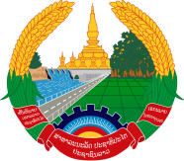

**Statement by the delegation of the Permanent Mission of the Lao PDR to the United Nations Office and other International Organizations in Geneva**

**At the 47th Session of the UPR Working Group**

**Geneva, 4-15 November 2024**

_________

**Review of Norway, 4 November 2024 (09:00-12:30 hours)**

* Mr. President,
* The Lao PDR warmly welcomes and thanks the distinguished delegation of Norway for the comprehensive report.
* My delegation commends the progress made by Norway in the promotion and protection of human rights since the last review, including achieving high degree of gender equality and the protection of child’s rights.
* The Lao PDR would like to offer two recommendations:

1. Strengthen national measures to advancing gender balance in education and labour market;
2. Continue efforts toward implementing the national plan against violence and abuse against children and domestic violence.

* I wish Norway a success in this UPR review.
* I thank you, Mr. President.