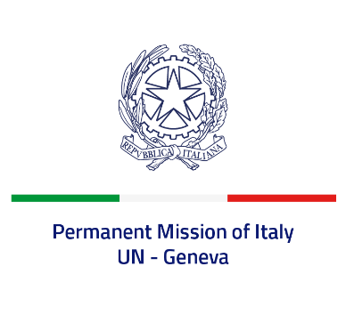

*Check against delivery*

**UPR 47 – Norway**

**Monday 4 November 2024, 9:00 – 12:30**

**Delivered by: Permanent Representative of Italy Amb. Vincenzo Grassi**

*Thank you, Mister President.*

We thank the distinguished delegation of Norway for their national report and presentation.

Italy appreciates the commitment of Norway to the promotion of human rights at international level and commends Norway for Government initiatives to combat discrimination, including the ‘*Action Plan 2024-2027 against Racism and Discrimination*’. We also noted favourably a decrease in total penitentiary confinement cases.

Italy seizes this opportunity to offer Norway the following recommendations:

*- Ensure that the decisions of the Child Welfare Services are compliant with the human rights of both the parents and the child, taking fully into consideration the relevant ECHR judgements, and guarantee a broad and effective communication with foreign consular authorities on cases involving their respective nationals.*

*- Consider further the ratification of the Optional Protocol to the Convention on the Rights of the Child on a communications procedure, the Optional Protocol to the International Covenant on Economic, Social and Cultural Rights, as well as the Optional Protocol to the Convention on the Rights of Persons with Disabilities.*

We wish Norway a successful review.

*I thank you.*