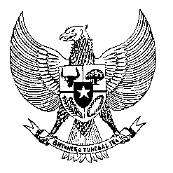

Permanent Mission

of the Republic of Indonesia to the UN, WTO,

and Other International Organizations

in Geneva

**STATEMENT BY THE DELEGATION OF THE REPUBLIC OF INDONESIA**

**AT THE 47th SESSION OF THE UPR WORKING GROUP**

**CONSIDERATION OF THE UPR REPORT OF NORWAY**

1. **NOVEMBER 2024**

* **Thank you Mr. President,**
* Indonesia welcomes the delegations of Norway and recognize their stated commitment to human rights.
* We encourage further efforts to address policy and implementation gaps.
* We note Norway’s acknowledgment of past human rights abuses against the Sámi and five national minorities and hope for further progress through meaningful actions and reparative measures.
* Additionally, we stresses that the rising incidence of hate speech requires robust laws and enforcement to protect affected communities.
* We also value Norway’s commitment to addressing impunity for atrocity crimes, and hope this extends to human rights violations in the OPT.
* In a spirit of constructive engagement, we recommend that Norway:

1. Intensify efforts to promote gender equality and support workforce participation, especially for women from minority backgrounds.
2. Strengthen climate adaptation through stakeholder consultations to support at-risk communities and ensure a healthy environment for all.
3. Ensure the effective implementation of action plans to address racism and discrimination, including measures against anti-Muslim hatred.

**Thank you.**