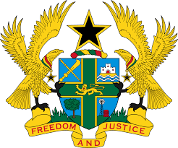

**STATEMENT DELIVERED BY GHANA DURING THE 47TH SESSION OF THE UNIVERSAL PERIODIC REVIEW WORKING GROUP ON MONDAY, 4TH NOVEMBER, 2024**

**UNIVERSAL PERIODIC REVIEW OF NORWAY**

Mr. President,

2. Ghana warmly welcomes the delegation of Norway and particularly commend the Government of Norway for the exemplary leadership role in fostering global consensus on matters of peace, security and sustainable development.

3. We also acknowledge Norway's strong dedication to safeguarding human rights through its efforts to revise its national guidelines on health services for detainees and inmates, including persons with psychological disabilities and severe mental health challenges. We further recognize the creation of a national grant scheme aimed at promoting anti-racism and diversity, as well as enhancing awareness among the general population regarding issues of discrimination and hate speech.

4. In the spirit of constructive dialogue, Ghana recommends that Norway:

1. **Ratify the Optional Protocol to the Convention on the Rights of Persons with Disabilities; and**
2. **Address concerns about the prevalence of some forms of institutional racism to effectively advance efforts aimed at ensuring inclusivity and equality.**

5. Ghana wishes Norway a successful review process.

I thank you.