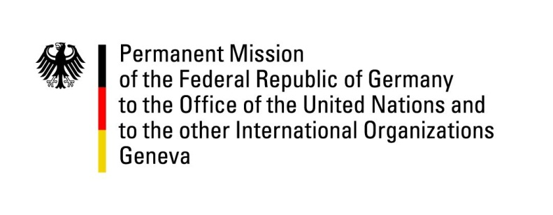

**United Nations Human Rights Council**

**47th Session of the UPR Working Group**

**Geneva, 4 November 2024**

**German Recommendations to Norway**

Mister President,

Germany welcomes the delegation of Norway, and highly commends Norway for its strong commitment to the protection of human rights as enshrined in its constitution.

Norway consistently ranks among the top countries on the Human Development Index regarding press freedom and transparency, and has made significant strides in gender equality. Additionally, the establishment and continued support of the National Human Rights Institution (NIM) demonstrates Norway’s serious approach to upholding human rights.

Further progress should be made in tackling challenges in areas such as child welfare, particularly regarding the issue of unaccompanied asylum-seeking minors.

Germany therefore recommends to:

* Strengthen efforts to protect the rights of unaccompanied asylum-seeking minors in asylum centers;
* Continue advancing the rights and protection of the Sami, Kven and Forest Finns, including through further actions to address past injustices;
* Enhance measures to combat hate speech and hate crimes, with a focus on effective implementation of existing action plans.

Thank you, Mister President.