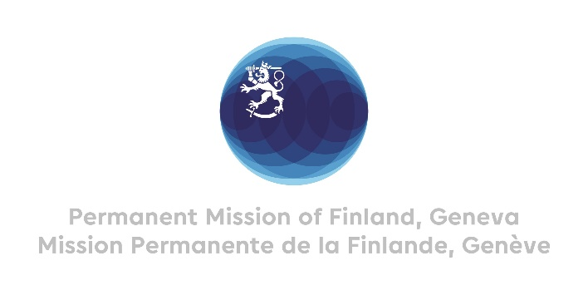

Mr. President,

Finland welcomes the engagement of Norway in the UPR process. We commend Norway for the 2023 action plan aimed at securing the rights of and improving the quality of life for LGBT+ persons, and fostering greater acceptance of gender and sexual diversity.

Finland wishes to make the following recommendations:

1. First, to continue efforts to ensure the right to inclusive education for women with minority background, including migrant women, and to improve the possibilities for them to enter the labour market,
2. Second, to continue targeted, systematic efforts to improve social attitudes towards and living conditions for LGBTQI+ persons,
3. Third, to consider ratifying the Optional Protocol to the International Covenant on Economic, Social and Cultural Rights.

Thank you.